Lab 7 Getting start with istio
- Download and install istio
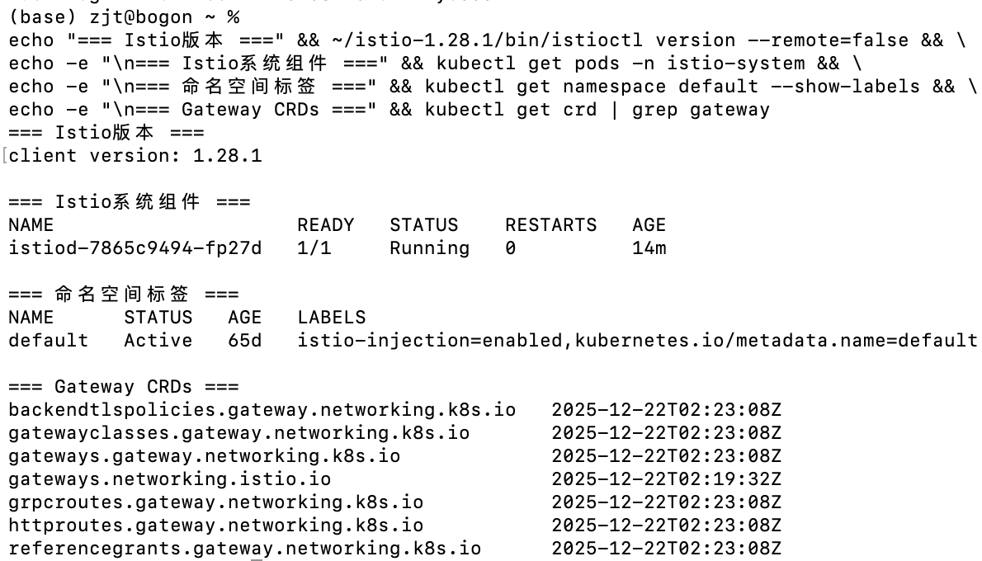

- Deploy the sample application
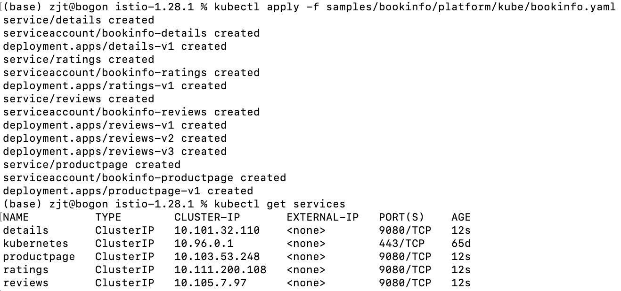
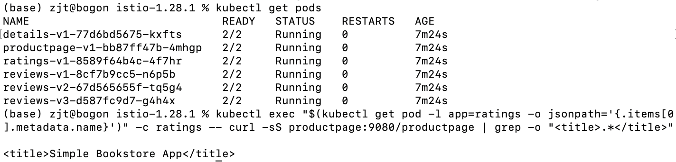
- Open the application to outside traffic
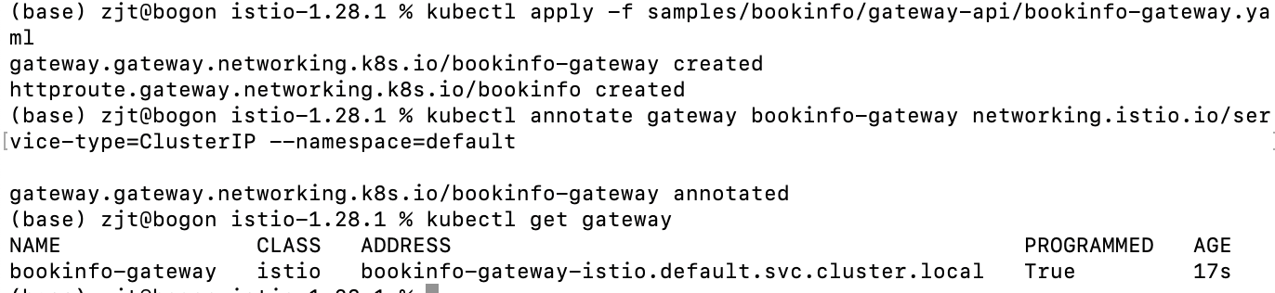

- Access the application
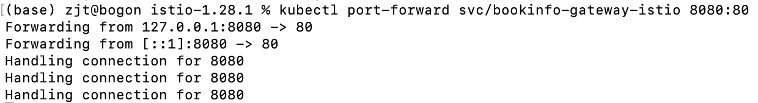
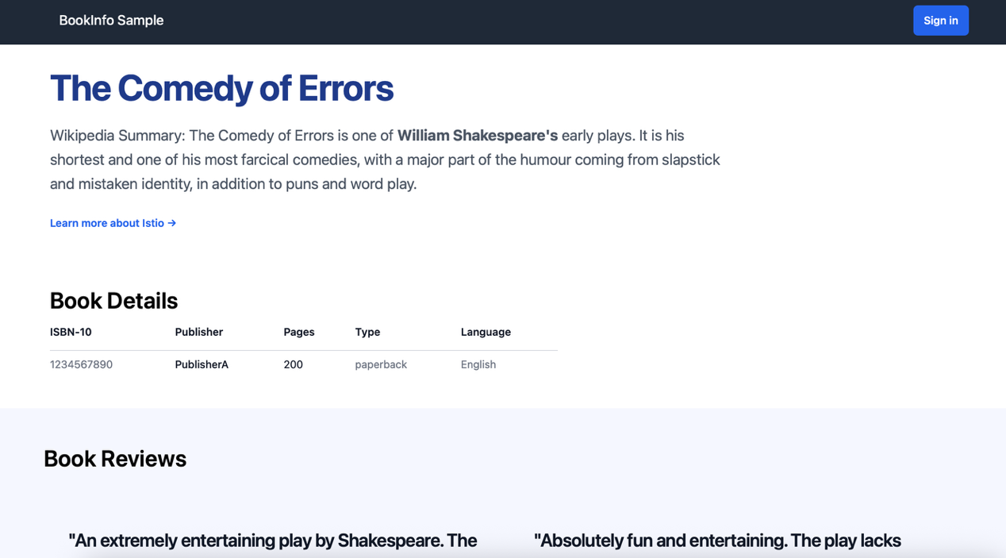

- View the dashboard
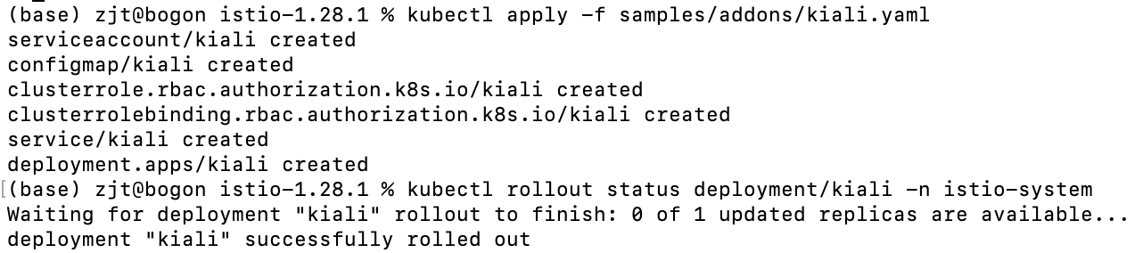
istioctl dashboard kiali
